Name: _______________________________ /49

**Year 7 Physics**

**Mid Topic Test**

**Multiple Choice**

***Multiple choice answer sheet. Shade in the one answer you think to be best.***

|  |  |
| --- | --- |
| ⒈ Ⓐ Ⓑ Ⓒ Ⓓ  ⒉ Ⓐ Ⓑ Ⓒ Ⓓ  ⒊ Ⓐ Ⓑ Ⓒ Ⓓ  ⒋ Ⓐ Ⓑ Ⓒ Ⓓ  ⒌ Ⓐ Ⓑ Ⓒ Ⓓ  ⒍ Ⓐ Ⓑ Ⓒ Ⓓ  ⒎ Ⓐ Ⓑ Ⓒ Ⓓ  ⒏ Ⓐ Ⓑ Ⓒ Ⓓ  ⒐ Ⓐ Ⓑ Ⓒ Ⓓ  ⒑ Ⓐ Ⓑ Ⓒ Ⓓ | 11 Ⓐ Ⓑ Ⓒ Ⓓ  12 Ⓐ Ⓑ Ⓒ Ⓓ  13 Ⓐ Ⓑ Ⓒ Ⓓ  14 Ⓐ Ⓑ Ⓒ Ⓓ  15 Ⓐ Ⓑ Ⓒ Ⓓ  16 Ⓐ Ⓑ Ⓒ Ⓓ  17 Ⓐ Ⓑ Ⓒ Ⓓ  18 Ⓐ Ⓑ Ⓒ Ⓓ  19 Ⓐ Ⓑ Ⓒ Ⓓ  20 Ⓐ Ⓑ Ⓒ Ⓓ |

|  |  |  |  |  |
| --- | --- | --- | --- | --- |
|  |  |  |  |  |
|  |  |  |  |  |
|  |  |  |  |  |
|  |  |  |  |  |
|  |  |  |  |  |
|  |  |  |  |  |
|  |  |  |  |  |
|  |  |  |  |  |
|  |  |  |  |  |
|  |  |  |  |  |
|  |  |  |  |  |
|  |  |  |  |  |
|  |  |  |  |  |

1. 1. The aircraft shown below has four forces acting on it.
2. 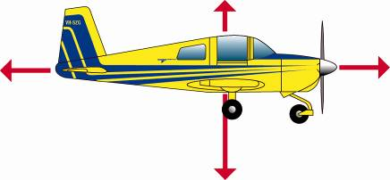
3. As a result of these forces, it will:

**A** Move to the right

**B** Move to the left

**C** Move up

**D** Move down

1. 2. A car moving in a straight line at constant speed:

**A** is accelerating.

**B** is decelerating.

**C** has no overall force acting on it.

**D** must be on a downhill slope.

1. 3. Trolleys are used to shift furniture because rolling surfaces produce:

**A**  more friction than sliding surfaces.

**B**  no friction.

**C**  less friction than sliding surfaces.

**D**  lots of heat which helps the furniture to move smoothly.

1. 4. A lubricant, such as oil:

**A** produces friction.

**B** reduces friction.

**C** increases friction.

**D** is a force caused by two surfaces moving over each other.

1. 5. It is more slippery walking on ice than walking on a footpath. This is because:

**A** there is more friction between the ice and your shoes.

**B** there is less friction between the ice and your shoes.

**C** your shoes get wet.

**D** you weigh less on ice than on the footpath.

1. 6. Weight is:

**A** the same as mass.

**B** constant throughout the universe.

**C** a force.

**D** the amount of matter in an object.

1. 7. Select the ***incorrect*** sentence about magnets.

**A** they can only apply a force when in contact.

**B** they can apply a force at a distance.

**C** They can only attract particular materials,

**D** They are used in many different places

1. 8. Select the response that is ***correct***.

**A** Air resistance is an example of friction.

**B** Air resistance is an example of magnetism.

**C** Air resistance occurs in space.

**D** Air resistance is an example of gravity.

1. 9. When an object is falling:

**A** it will decelerate until it reaches maximum velocity.

**B** it will accelerate until it reaches terminal velocity.

**C** it will accelerate until it hits the ground.

**D** it will decelerate until it hits the grond.

1. 10. The size of a force can be:

**A** measured in grams using a ruler.

**B** measured in litres using a spring balance,

**C** measured in newtons using a spring balance.

**D** measured in newtons using a measuring cylinder.

1. 11. Choose the statement that is TRUE.

**A** If the forces acting on an object are balanced, then it is not moving.

**B** You supply a force when you squeeze a tube of toothpaste.

**C** Inertia describes the tendency of an object to change its motion.

**D** The less mass an object has, the greater its inertia.

1. 12. For an aircraft to successfully take off, the lift force provided by its wings must be greater than the aircraft’s weight force pulling it down. The thrust provided by its engine must also be greater than any drag forces pulling it backwards. To fly in the air, forces are balanced. A successful landing is the reverse process of the launch.
2. 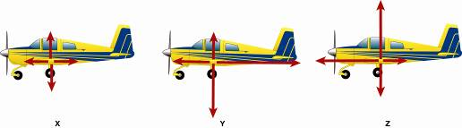
3. The order of diagrams that demonstrates the combination of force pairs required for an aircraft take-off, cruising at altitude, and a safe landing is:

**A** X, Y, Z

**B** Y, X, Z

**C** Z, Y, X

**D** Z, X, Y

1. 13. Look at the diagram below and use it to answer the question that follows. The diagrams show a coin sitting on a card. Someone is about to flick the card.
2. 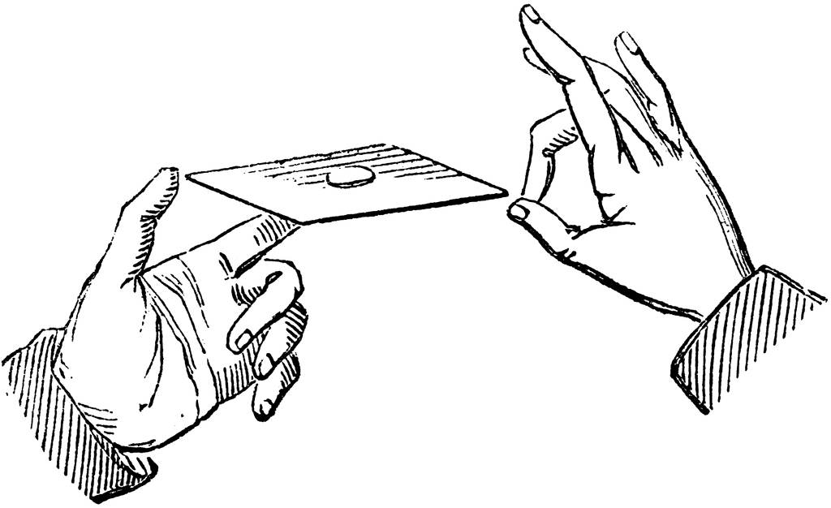
3. A The coin will fly off with the card due to shared inertia.
4. B The coin will remain in approximately the same position due to inertia.
5. D The coin is held in place due to magnetic force.
6. D The card will not move due to inertia.
7. 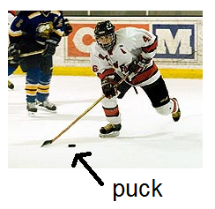14. Analyse the following and rate them in order from those that would experience the most friction to those that would experience the least friction.

i) a couch being dragged across carpet.

ii) a waxed pair of skis travelling on snow.

iii) an ice-hockey puck hit across the ice.

iv) a child’s tricycle being pulled along the footpath.

**A** iv, ii, iii, i

**B** ii, iii, iv, i

**C** iv, iii, i, ii

**D** i, iv, ii, iii

1. 15. Choose the statement that is **TRUE**.

**A** An elephant has greater inertia than a mouse.

**B** A person inside a bus that is turning left will lean to their left side.

**C** Gravity is a contact force.

**D** Weight is measured in kilograms.

1. 16. Physics is the study of:

**A** chemicals.

**B** living things.

**C** stars.

**D** energy.

1. 17. If you were to stand on a pair of scales at a height of 100 km above the surface of the Earth:

**A** the reading would be the same as it is on the Earth’s surface.

**B** the reading on the scales would be greater.

**C** the reading on the scales would be lower.

**D** there would be no reading on the scales.

18. A leaf and a pebble of the same mass are dropped from the same height at the same time. Which would hit the ground first?

**A** The leaf.

**B** The pebble.

**C** They would both hit the ground at the same time.

**D** There is not enough information to answer this.

19. Look at the table below and use to answer the question that follows.

|  |  |
| --- | --- |
| **Body** | **Mass [kg]** |
| Sun | 1.99 x 1030 |
| Venus | 4.88 x 1024 |
| Earth | 5.98 x 1024 |
| Moon | 7.36 x 1022 |
| Jupiter | 1.90 x 1027 |

From this table we can state that?

A an object on Jupiter will weigh more than the same object on the Earth.

B an object on Venus will weigh less than an object on Jupiter.

C an object on the moon will have no weight.

D The sun has less gravity than Venus.

20. When a ball is thrown:

A the force pushing it forward is slowed by gravity and air resistance.

B the force pushing it forward is slowed by the Earth’s magnetic field and air resistance.

C the force pushing it forward is never equalled by air resistance.

D the force of pulling it forward is the force of impact.

**Short Answer**

1. 1. Classify each of these actions as a **push,** **pull** or **twist** force. (5 marks)

a) Sweeping the floor. ___________________________

b) Dragging a heavy sports bag along the floor. ___________________________

c) Throwing a cricket ball. ___________________________

d) Hitting a golf ball. ___________________________

e) Tightening a screw using a screwdriver. ___________________________

1. 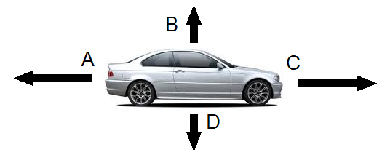2. This car is moving forward at a constant speed. Forces B and D acting on the car are equal in size.

a. Draw the arrows on the car below to show it is accelerating (speeding up) (2 marks)

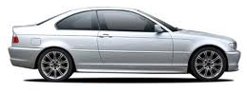

b. Draw arrows on the car below to show it is decelerating (slowing down) (2 marks)



3. Fill in the table below

|  |  |
| --- | --- |
| Word | Meaning |
| Force |  |
| Friction |  |
| Gravity |  |

(3 marks)

4. Box A has a mass of 200kg. Box B has a mass of 20kg. (3 marks)

Which would have the greater friction? ________________

Friction exists between the bottom surface of the _______________ and the ____________________.

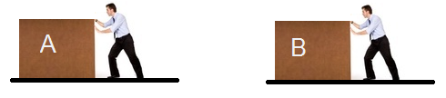

5. Fill in the table below with the correct method of friction reduction. Choose from the methods below. (7 marks)

|  |  |
| --- | --- |
| **SITUATION** | **Method of friction reduction.** |
| http://www.quotify.com.au/files/quotify/removals/images/02_trolley.jpg |  |
| http://static.ddmcdn.com/gif/water-slide-5.jpg |  |
| http://web.tradekorea.com/upload_file2/product/701/P00290701/cbe9caa5_1a6739e8_d38a_4a33_be1c_57337320a88c.jpg |  |
| http://t0.gstatic.com/images?q=tbn:ANd9GcSve8Fc1lSByBRGg44cGSQub1l4xV6HnJU9LYKpTiEPuxb_bkfFiU1VQa66 |  |
| http://static.ddmcdn.com/gif/lifetime-engine-oil-1.jpg |  |
| http://content5.videojug.com/f3/f38a9286-b936-0e89-25cb-ff0008ca4e83/replacement-for-how-to-stop-squeaky-hi-2.WidePlayer.jpg?v4 |  |
|  |  |

6. The table below shows the drag coefficient of number of cars. The drag coefficient measures the effect air resistance has on a cars ability to move through air.

a. Draw a suitable table for the data in the table below. (5 marks)

|  |  |
| --- | --- |
| **Car** | **Drag Coefficient Cd** |
| **Mazda3 Sedan: 2012** | **0.26** |
| **Bus** | **0.6** |
| **Ford Ranger 4wd** | **0.5** |
| **Jeep Grand Cherokee** | **0.42** |

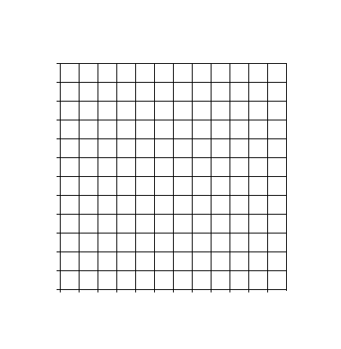

b. If all of the vehicles where the same mass, were travelling at the same speed and had the same motor, which car would use the least fuel? Give a reason for your answer.

_______________________________________________________________________________________________________________________________________________________________________________________________________________________________________________________________________________________________________________

(2 marks)